Hospital Management Dashboard – Insight Summary
Prepared by Shakira
shakirashakijsnz@gmail.com
📊 Project Overview
This Power BI dashboard provides a comprehensive analysis of hospital operations, covering patient trends, treatment performance, financial insights, and overall business efficiency. The analysis helps stakeholders make data-driven decisions to improve service quality and revenue performance.

Data Modeling
A star schema was implemented with Appointments as the central fact table connected to Patients,
Doctors, Treatments, and Billing tables using Patient_ID, Doctor_ID, and Appointment_ID.
One-to-many relationships were ensured and circular relationships were avoided.
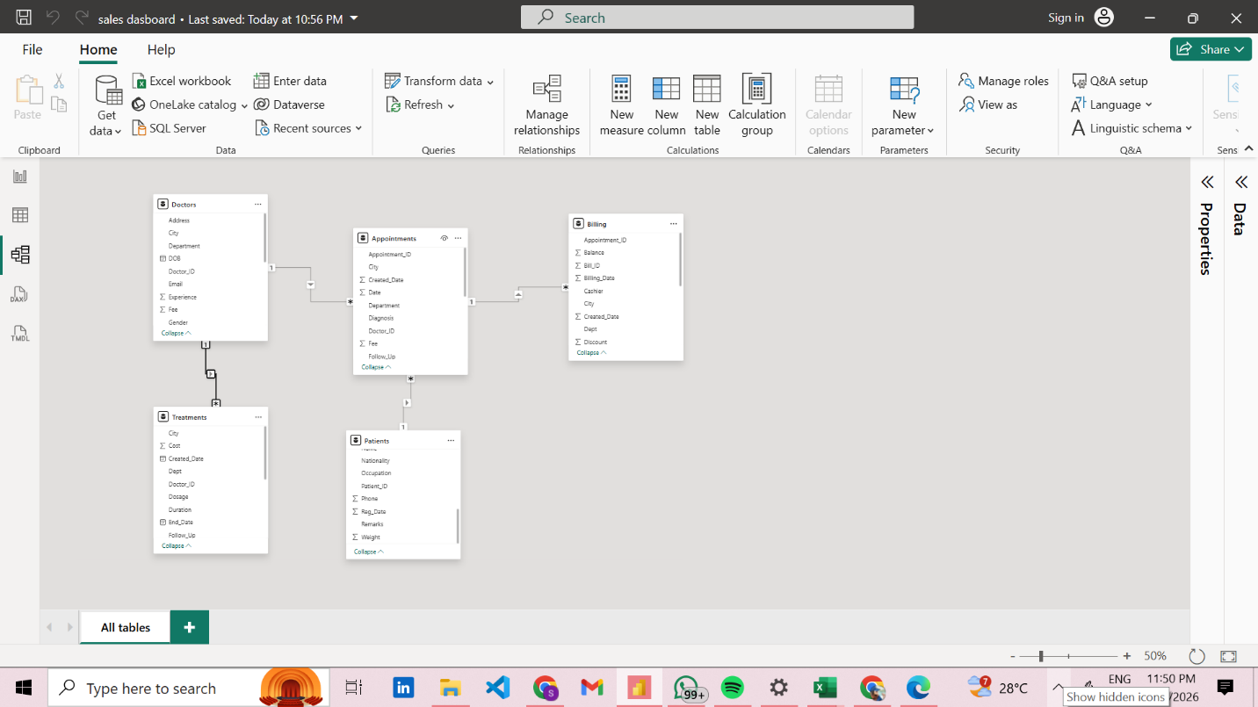
DAX Calculations
Key measures created include:
• Total Revenue = SUM(Billing[Final])
• Total Appointments = COUNT(Appointments[Appointment_ID])
• Average Billing = AVERAGE(Billing[Final])
• Pending Payments = SUM(Billing[Balance])
• Treatment Completion Rate calculated using Follow_Up status
5 Business Insights
1. Revenue Concentration in Key Departments
A significant portion of total revenue is generated by a few departments (such as Cardiology and Neurology), indicating these are high-performing and high-demand areas.

2. Patient Distribution is City-Centric
Major cities like Bangalore, Mumbai, and Hyderabad contribute the highest number of patients, highlighting strong regional demand and potential for expansion.

3. Treatment Demand is Uneven
Certain treatments (like Medication and Surgery) dominate the distribution, suggesting higher dependency on specific healthcare services.

4. Appointment Trends Show Fluctuations
Appointments vary across time, indicating possible seasonal trends or operational inefficiencies in scheduling.

5. Payment Completion Rate is Moderate
A noticeable portion of payments remains pending, indicating that revenue collection is not fully optimized.

2 Risk Observations
1. High Pending Payments Risk
A large amount of outstanding balance (pending payments) can impact hospital cash flow and financial stability.

2. Treatment Completion Gap
The difference between completed and ongoing treatments indicates possible delays or inefficiencies in treatment processes.

2 Improvement Suggestions
- Improve Payment Collection System

- Implement automated payment reminders
- Introduce digital payment options
- Offer early payment incentives

This will improve cash flow and reduce pending balances.

2. Optimize Treatment & Scheduling Efficiency
- Improve appointment scheduling system
- Monitor ongoing treatments closely
- Allocate resources based on demand
This will increase treatment completion rate and patient satisfaction.

Dashboard Images

Page 1
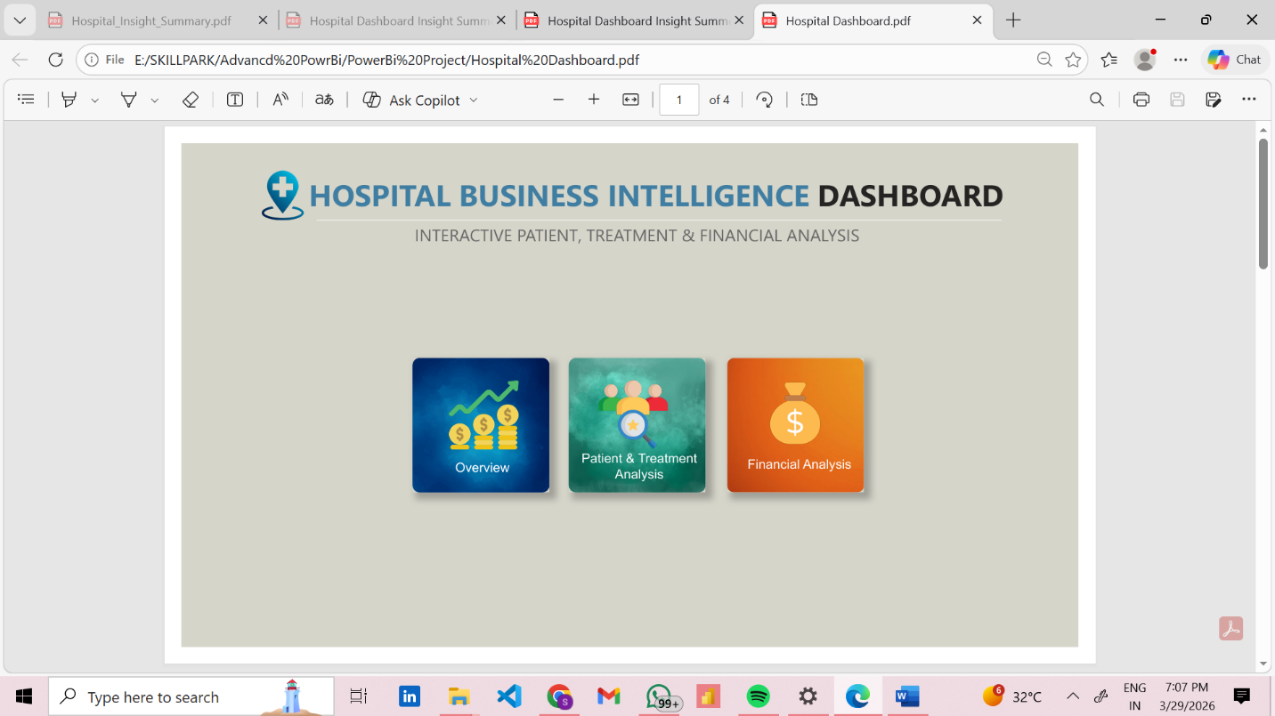

Page 2
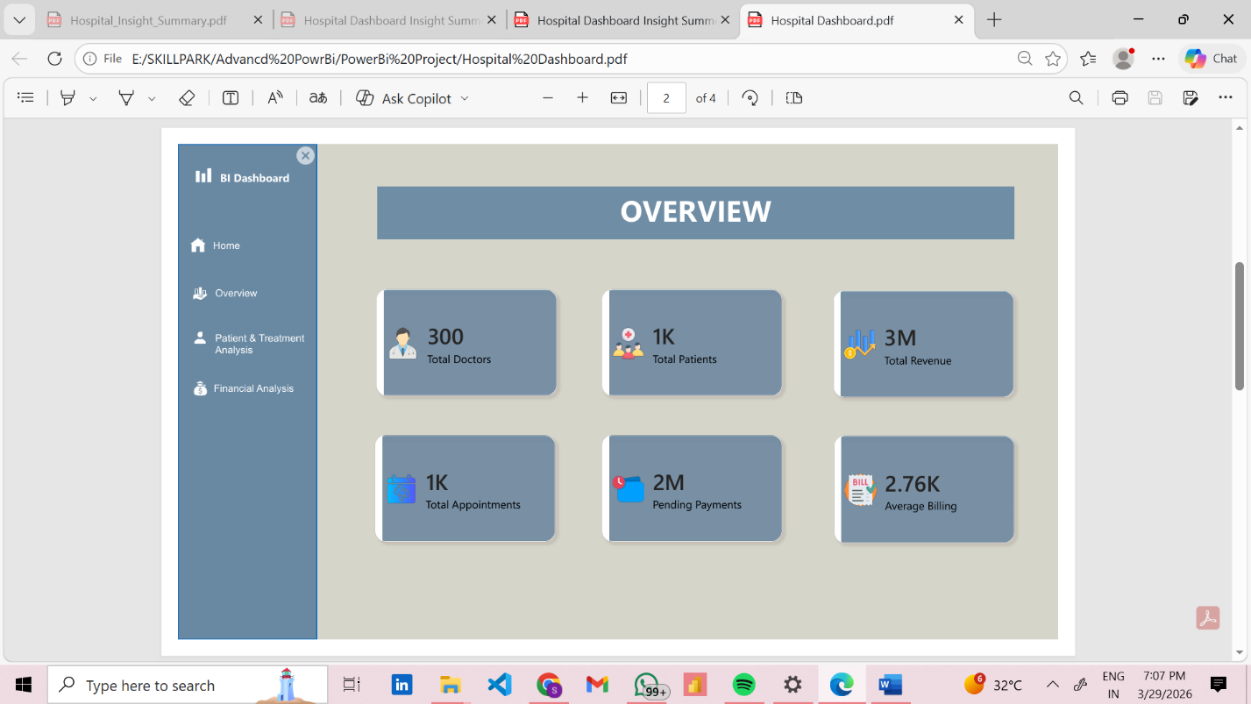

Page 3
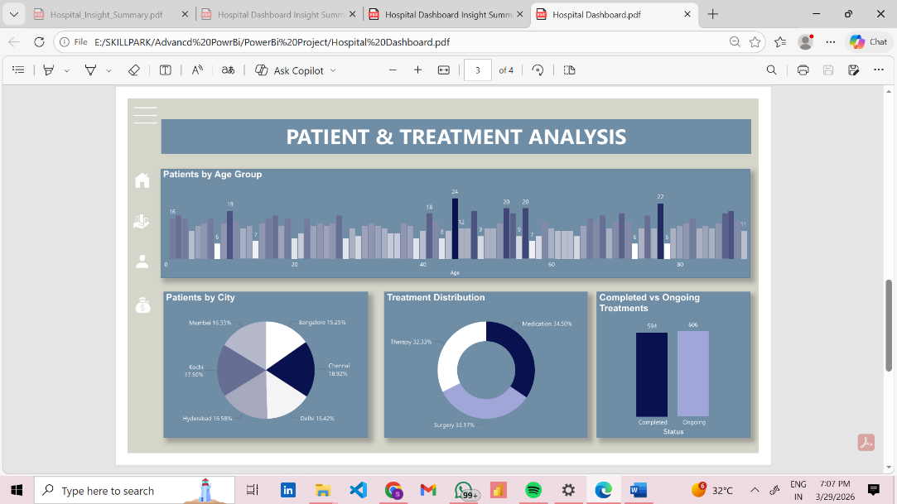

Page 4
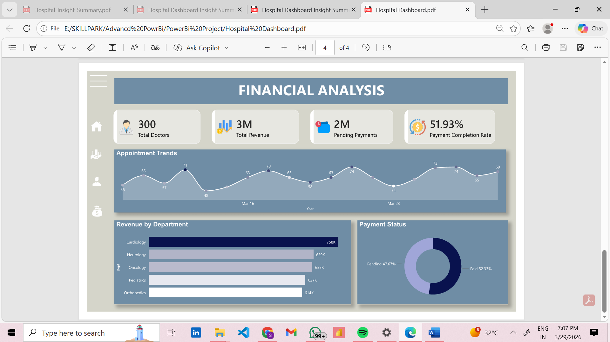

Conclusion
The dashboard highlights key operational and financial areas of the hospital. While revenue generation is strong, improvements in payment collection and treatment efficiency can significantly enhance overall performance. Leveraging these insights will help in strategic

